Phenix Payton
NET 2300
Job execution log
4/1/26
./ingress-db.sh runs:
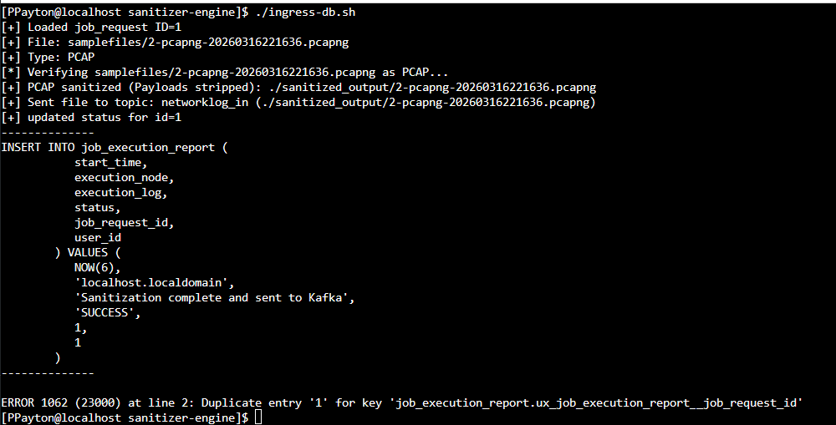
(Successfully updates to job_execution_report, still debugging the duplicate entry error)
